**Pankaj Solanki**

**Group – Data Analytics**

**Analysis of Super Store Data**

**Queries:**

Q1) Plot a pie-chart to find the Ship Mode through which most of the orders are being delivered.

a) Standard Class

b) First Class

c)Second Class

d)Same Day

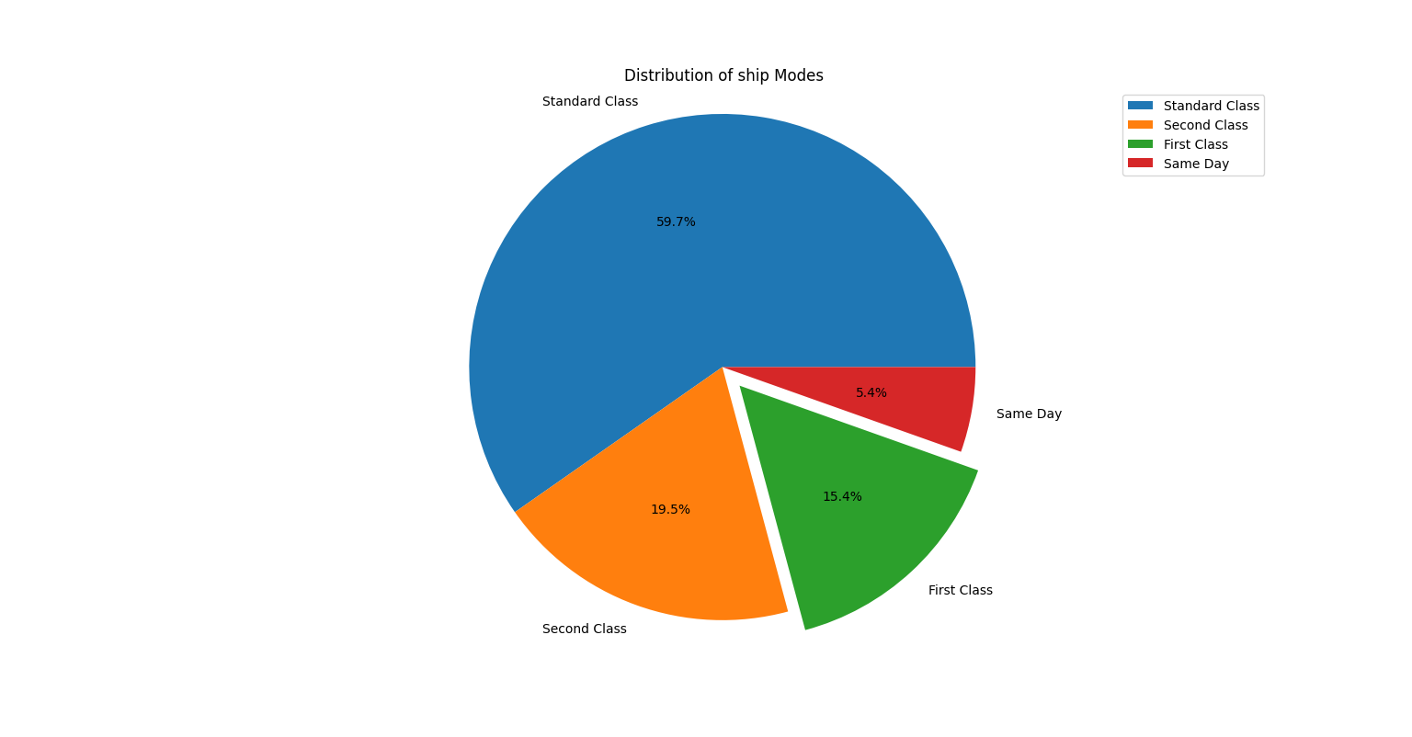**Analytical Result: - Graph 1: Distribution of Ship Modes**

Q2) Plot a bar chart comparing the average `Discount` across all the `Regions` and report back the `Region` getting the highest average discount

Note- You need to clean the `Discount` column first

a) Central

b) South

c)West

d)East

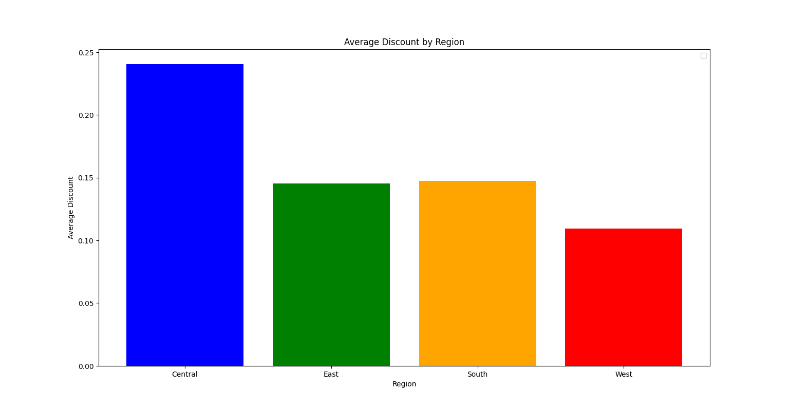**Analytical Result: - Graph 2: Distribution of Discount Over Regions**

**Some Extra Graphs for deep Analysis: -**

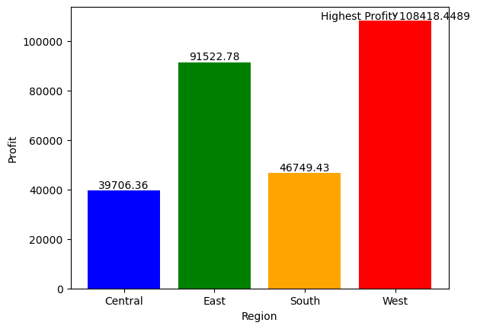**Graph 3: Distribution of Profit over Regions**

Region with the highest profit: West

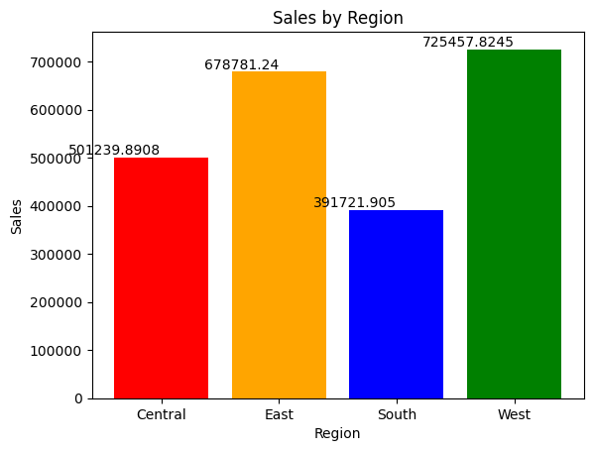**Graph 4: Distribution of Sales over Regions**

Region with the highest sales: West

**My Analysis of the Data set given is as follow: -**

**Graph 1: Distribution of Ship Modes**

The first graph illustrates the distribution of ship modes and their respective percentages of order delivery. The analysis reveals the following findings:

* Standard Class: The most prevalent ship mode is the "Standard Class," accounting for approximately 59.7% of the total order deliveries. This mode is favored by the majority of customers, indicating its popularity and efficiency.
* Second Class: The second most frequently used ship mode is "Second Class," comprising approximately 19.5% of the overall order deliveries. Although lower than the standard class, this mode still holds a significant share of deliveries.
* First Class: The "First Class" ship mode represents approximately 15.4% of the total orders delivered. While it falls behind the standard and second class, it remains a considerable portion of the shipments.
* Same Day: The remaining orders, approximately 5.4%, are shipped using the "Same Day" mode. Although the smallest percentage, it is worth noting that this ship mode is reserved for urgent deliveries, where speed is of utmost importance.

**Graph 2: Distribution of Discount over Region**

The first graph presents a comprehensive overview of the distribution of discounts across different regions. It provides a visual representation of the average discount values observed in each region.

* Central Region: The central region stands out with the highest average discount among all regions. This indicates that discounts in this region are more prevalent or potentially more significant compared to other regions.
* West Region: In contrast, the west region demonstrates the lowest average discount. This suggests that discount strategies in this region may not be as pronounced or effective as in other areas.
* East and South Regions: The average discounts in the east and south regions are relatively similar, indicating a comparable level of discounting activity. These regions fall between the high-discount central region and low-discount west region

**Graph 3: Distribution of Profit over Region**

**West Region:**

* The West region stands out with the highest profit of 108,418.45.
* This can be attributed to the West region having the least average discount compared to other regions.
* The lower discount rates in the West region contribute to higher profit margins.
* The strong performance of the West region indicates a successful sales strategy and effective pricing management.

**East Region:**

* The East region follows closely with a profit of 91,522.78.
* Despite not surpassing the West region in terms of profit, the East region still demonstrates a solid performance.
* It benefits from relatively lower average discounts compared to the Central and South regions.
* The East region's profitability indicates a favorable market response and efficient cost management.

**South Region:**

* The South region shows a profit of 46,749.43, positioning it third among the regions.
* While it lags behind the West and East regions, it still maintains a respectable level of profitability.
* The South region's profit is influenced by the average discount rates offered, although they are higher than those in the West and East regions.
* Optimizing discount strategies in the South region may help further improve its profitability.

**Central Region:**

* The Central region exhibits the lowest profit among the regions, with 39,706.36.
* This lower profit can be attributed to the highest average discount offered in comparison to the other regions.
* The higher discount rates in the Central region impact profit margins negatively.
* Implementing measures to optimize pricing and discount strategies in the Central region may help boost profitability.

**Graph 4: Distribution of Sales over Region**

The fourth graph focuses on the Distribution of Sales by Region. It reveals the number of sales made in each region, providing insights into the sales performance across different geographical areas.

* The West region stands out as the region with the highest number of sales, reaching 725,457.82. This high sales figure directly contributes to generating a higher profit for the West region compared to other regions.
* Following closely is the East region, which demonstrates a significant sales volume of 678,781.24. This indicates a strong market presence and consumer demand in the East region.
* The Central region secures the third position in terms of sales, with a total of 501,239.89. Interestingly, despite offering the highest average discount among all the regions, the sales performance in the Central region remains relatively strong. This suggests that even with higher discounts, customers in this region are still inclined to make purchases.
* Lastly, the South region reports a sales figure of 391,721.90, representing the lowest among all the regions analyzed. Further exploration and evaluation of the South region's market dynamics may be required to identify potential strategies for improvement.